Updating the SAP NetWeaver to Support Standard Account Attributes
The following outlines the steps required to add the "Floor" attribute to the ITIM Adapter for SAP NetWeaver.
1). Extract the profile associated with the ITIM Adapter for SAP NetWeaver.
2). Adding the ersapnwfloor attribute to the SAP NetWeaver ISIM schema.dsml –
<!-- ******************************************************** -->
<!-- ersapnwbuilding -->
<!-- ******************************************************** -->
<attribute-type single-value = "true" >
<name>ersapnwbuilding</name>
<description>building</description>
<object-identifier>1.3.6.1.4.1.6054.3.149.2.6</object-identifier>
<syntax>1.3.6.1.4.1.1466.115.121.1.15</syntax>
</attribute-type>

<!-- ******************************************************** -->
<!-- ersapnwfloor -->
<!-- ******************************************************** -->
<attribute-type single-value = "true" >
<name>ersapnwfloor</name>
<description>floor number</description>
<object-identifier>1.3.6.1.4.1.6054.3.64.2.19</object-identifier>
<syntax>1.3.6.1.4.1.1466.115.121.1.15</syntax>
</attribute-type>

3). Update the ersapnwaccount attribute to include the floor attribute -

<!-- ******************************************************** -->
<!-- ersapnwaccount class -->
<!-- ******************************************************** -->
<class superior="top">
<name>ersapnwaccount</name>
<description>sap account class</description>
…..
<attribute ref = "ersapnwfunction" required="false"/> <!-- sapAddress/function -->
<attribute ref = "ersapnwfloor" required="false"/> <!-- sapAddress/floor -->
<attribute ref = "ersapnwbuilding" required="false"/> <!-- sapAddress/buildingNumber -->
…

4). Add the following to the CustomLabels.properties file -

ersapnwalias=Internet User Alias
ersapfloor=Floor
ersapnwbuilding=Building

5). Adding the floor attribute to the account ersapnwaccount.xml -

<formElement direction="inherit" label="$ersapnwroom" name="data.ersapnwroom">
<input type="text" name="data.ersapnwroom"/>
</formElement>
<formElement direction="inherit" label="$ersapfloor" name="data.ersapfloor">
<input type="text" name="data.ersapfloor"/>
</formElement>
<formElement direction="inherit" label="$ersapnwbuilding" name="data.ersapnwbuilding">
<input type="text" name="data.ersapnwbuilding"/>
</formElement>

6). Repackage the profile by executing the following command -

#> cd SapNWProfile

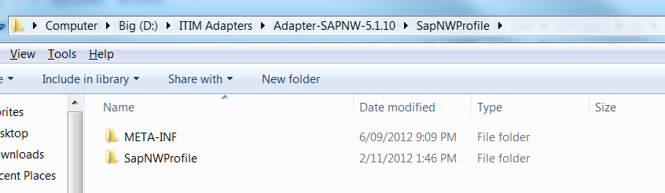

#> jar -cvf SapNWProfile.jar *

7). Reimport the updated profile using the ISIM interface -

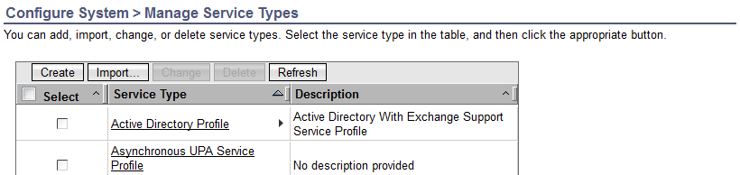

8). Confirm that the import of the new profile has completed successfully via the ISIM tracce.log.

9). Confirm that the "Floor" attribute has been added to the SAP NetWeaver Account forms as shown following -

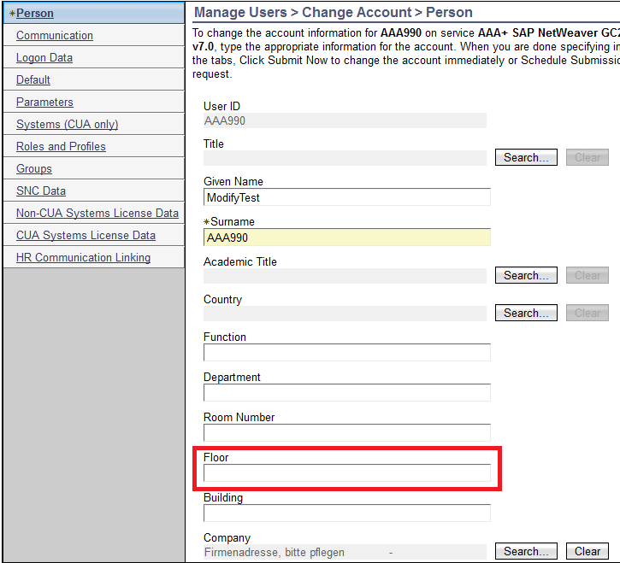

* Note – this may take a couple of minutes to propagate across all accounts.

10). Log into the TDI machine and navigate to the XSL files provided with the adapter.

11). Edit the "sapnw_bapi_user_create.xsl" file with the following contents marked in bold to add support for the “floor” attribute for the create account operation -

ADD -

<ADDRESS>
<xsl:apply-templates select="./ersapnwtitle" />
<xsl:apply-templates select="./ersapnwacademic" />
<xsl:apply-templates select="./ersapnwgivenname" />
<xsl:apply-templates select="./ersapnwsurname" />
<xsl:apply-templates select="./ersapnwcommlang" />
<xsl:apply-templates select="./ersapnwdepartment" />
<xsl:apply-templates select="./ersapnwfunction" />
<xsl:apply-templates select="./ersapnwbuilding" />
<xsl:apply-templates select="./ersapfloor" />
<xsl:apply-templates select="./ersapnwroom" />
<xsl:apply-templates select="./ersapnwcountry" />
<xsl:apply-templates select="./ersapnwsystimezone" />
<xsl:apply-templates select="./ersapnwcommmeth" />
<xsl:apply-templates select="./ersapnwprimaryphonenumber" />
<xsl:apply-templates select="./ersapnwprimaryphoneextension" />
<xsl:apply-templates select="./ersapnwprimaryfaxnumber" />
<xsl:apply-templates select="./ersapnwprimaryfaxextension" />
</ADDRESS>

ADD -

<xsl:template match="ersapnwbuilding">
<BUILDING_P><xsl:value-of select="." /></BUILDING_P>
</xsl:template>
<xsl:template match="ersapfloor">
<FLOOR_P><xsl:value-of select="." /></FLOOR_P>
</xsl:template>

12). Save and close the file.

13). Edit the "sapnw_bapi_user_change.xsl" file with the following contents marked in bold to add support for the floor attribute for the modify account operation -

ADD -

<xsl:output method="xml"
indent="yes"
omit-xml-declaration="yes"
cdata-section-elements="BAPI_USER_CHANGE USERNAME PASSWORD BAPIPWD PASSWORDX
ALIAS USERALIAS ALIASX BAPIALIAS ADDRESS ADDRESSX TITLE_P
TITLE_ACA1 FIRSTNAME LASTNAME LANGUP_ISO DEPARTMENT
FUNCTION BUILDING_P FLOOR_P ROOM_NO_P COUNTRY TIME_ZONE COMM_TYPE
TEL1_NUMBR TEL1_EXT FAX_NUMBER FAX_EXTENS COMPANY COMPANYX
DEFAULTS DEFAULTSX STCOD START_MENU SPLD SPDB SPDA DATFM
DCPFM LANGU CATT KOSTL CATTKENNZ LOGONDATA GLTGV GLTGB
USTYP CLASS ACCNT TZONE LTIME CODVN LOGONDATAX SNC PNAME
GUIFLAG SNCX GROUPS GROUPSX USERGROUP item PARAMETER
PARAMETERX PARID PARVA ADDSMTP ADDCOMX STD_NO E_MAIL
HOME_FLAG CONSNUMBER"/>

ADD -

<xsl:apply-templates select="./ersapnwbuilding" />
<xsl:apply-templates select="./ersapfloor" />

ADD –

<xsl:if test="./ersapnwbuilding">
<BUILDING_P>X</BUILDING_P>
</xsl:if>
<xsl:if test="./ersapfloor">
<FLOOR_P>X</FLOOR_P>
</xsl:if>

ADD -

<xsl:template match="ersapnwbuilding">
<BUILDING_P><xsl:value-of select="." /></BUILDING_P>
</xsl:template>
<xsl:template match="ersapfloor">
<FLOOR_P><xsl:value-of select="." /></FLOOR_P>
</xsl:template>

14). Save and close the file.

15). Edit the "sapnw_bapi_user_getdetail_postcall.xsl" file with the following contents marked in bold to add support for the floor attribute for the recon operation -

ADD -

<xsl:output method="xml"
indent="yes"
omit-xml-declaration="yes"
cdata-section-elements="User objectclass sapUserName eruid entryDN ersapnwalias ersapnwtitle
ersapnwacademic ersapnwgivenname ersapnwsurname ersapnwcommlang
ersapnwdepartment ersapnwfunction ersapnwbuilding ersapfloor ersapnwroom
ersapnwcountry ersapnwprimaryphonenumber ersapnwprimaryphoneextension
ersapnwprimaryfaxnumber ersapnwprimaryfaxextension ersapnwcommmeth
ersapnwcompany eraccountstatus ersapnwmenu ersapnwoutputdevice
ersapnwprntdelete ersapnwprntimmediate ersapnwdateformat
ersapnwdecimalpoint ersapnwdefaultlang ersapnwcatt ersapnwcostcenter
ersapnwdatefrom ersapnwdateuntil ersapnwtype ersapnwusergroups
ersapnwldaccount ersapnwtimezone codeVerEncryption
ersapnwsncname ersapnwsncflag ersapnwgroup item ersapnwparid
ersapnwemailaddress ersapnwagrname ersapnwprofile ersapnwcuasystem
ersapnwlicutype ersapnwlicspecver ersapnwlicsurchrg ersapnwlicsubfrom
ersapnwlicsubto ersapnwlicsysid ersapnwlicclient ersapnwlicbname
ersapnwliccuadata"/>

<xsl:template match="/">

ADD -

<!-- BEGIN sapAddress -->
<xsl:template match="ADDRESS" >
<xsl:apply-templates select="./TITLE_P" />
<xsl:apply-templates select="./TITLE_ACA1" />
<xsl:apply-templates select="./FIRSTNAME" />
<xsl:apply-templates select="./LASTNAME" />
<xsl:apply-templates select="./LANGUP_ISO" />
<xsl:apply-templates select="./DEPARTMENT" />
<xsl:apply-templates select="./FUNCTION" />
<xsl:apply-templates select="./BUILDING_P" />
<xsl:apply-templates select="./FLOOR_P" />
<xsl:apply-templates select="./ROOM_NO_P" />
<xsl:apply-templates select="./COUNTRY" />
<xsl:apply-templates select="./TEL1_NUMBR" />
<xsl:apply-templates select="./TEL1_EXT" />
<xsl:apply-templates select="./FAX_NUMBER" />
<xsl:apply-templates select="./FAX_EXTENS" />
<xsl:apply-templates select="./COMM_TYPE" />
</xsl:template>

ADD -

<xsl:template match="BUILDING_P">
<ersapnwbuilding><xsl:value-of select="." /></ersapnwbuilding>
</xsl:template>
<xsl:template match="FLOOR_P">
<ersapfloor><xsl:value-of select="." /></ersapfloor>
</xsl:template>

16). Save and close the file.

17). Restart the RMI Dispatcher to ensure that all the changes are picked up.

18). Test the add operation by creating a new account with the floor attribute set -

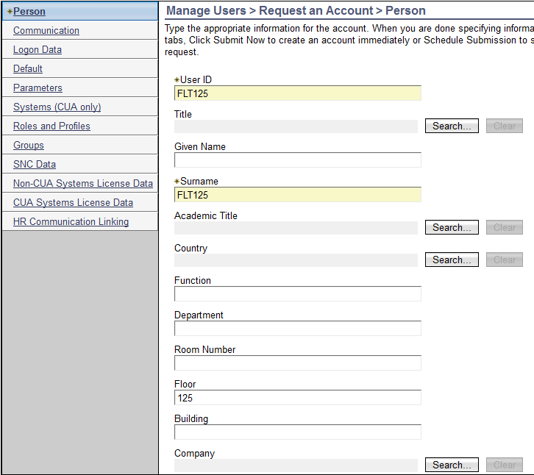

19). Validate that the operation has completed successfully using the ITIM GUI -

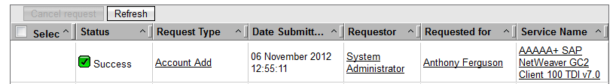

20). Validate that the operations has complete successfully within the SAP NetWeaver server using transaction code su01 -

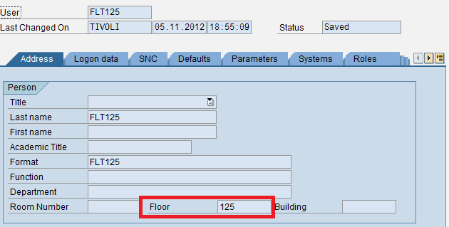

21). Complete a modify operation and validate that the operation has been completed successfully in both the ITIM and SAP GUI.

22). Modify the "Floor" attribute within the SAP GUI and complete a recon within the ITIM GUI for the service where the account exists. Validate that the recon operation has completed successfully and the account attribute in the ITIM account now matches that in the SAP GUI.

